SHD smoke Results:

1, unrepaired:
# run 1000ns
============================================================
PINES SHD seed 1701 XSim smoke test
variant=unrepaired sample_index=0
============================================================
Final prediction: RTL=15 golden=15
PASS: all 50 timesteps are bit-exact for membrane/spikes/logits.
============================================================
$finish called at time : 541 ns
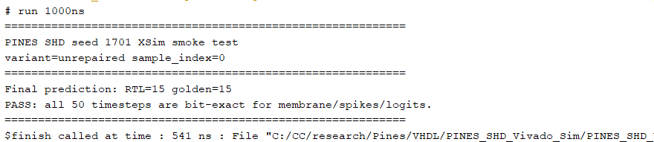
很好，这就说明 seed 1701 / unrepaired / sample 0 这条链已经完整闭环了：
- 50 个 timestep 的 membrane：bit-exact
- hidden spikes：bit-exact
- 20-class logits：bit-exact
- final prediction：RTL = 15，golden = 15
- 总仿真时间：541 ns
这比“最终分类一致”更强，因为现在已经证明 RTL 在整个 trajectory 上都和 artifact emulator 一致。

2, repaired sample 0:
# run 1000ns
============================================================
PINES SHD seed 1701 XSim smoke test
variant=repaired sample_index=0
============================================================
Final prediction: RTL=12 golden=12
PASS: all 50 timesteps are bit-exact for membrane/spikes/logits.
============================================================
$finish called at time : 541 ns
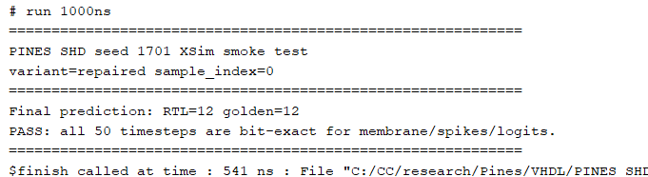
跑 repaired sample 0，确认 prediction = 12，且 50 timestep 全部 bit-exact。

3, 跑 artifact 提供的前 8 个 smoke samples，原始/修复版本都测:
Repaired sample 1:
# run 1000ns
============================================================
PINES SHD seed 1701 XSim smoke test
variant=repaired sample_index=1
============================================================
Final prediction: RTL=14 golden=14
PASS: all 50 timesteps are bit-exact for membrane/spikes/logits.
============================================================
$finish called at time : 541 ns
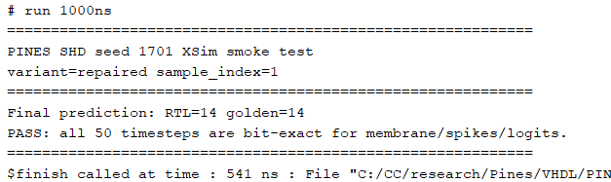

Repaired sample 2:
# run 1000ns
============================================================
PINES SHD seed 1701 XSim smoke test
variant=repaired sample_index=2
============================================================
Final prediction: RTL=11 golden=11
PASS: all 50 timesteps are bit-exact for membrane/spikes/logits.
============================================================
$finish called at time : 541 ns
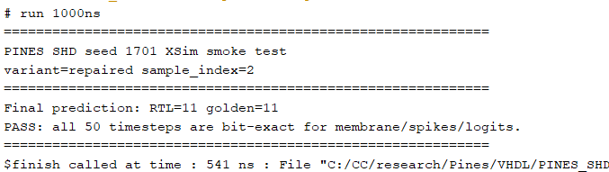

Repaired sample 3:
# run 1000ns
============================================================
PINES SHD seed 1701 XSim smoke test
variant=repaired sample_index=3
============================================================
Final prediction: RTL=9 golden=9
PASS: all 50 timesteps are bit-exact for membrane/spikes/logits.
============================================================
$finish called at time : 541 ns
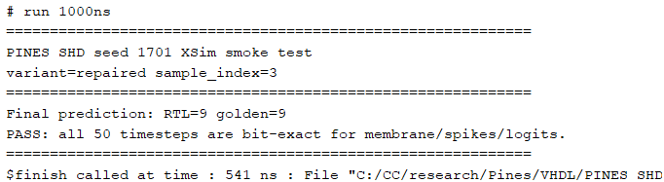

Repaired sample 4:
# run 1000ns
============================================================
PINES SHD seed 1701 XSim smoke test
variant=repaired sample_index=4
============================================================
Final prediction: RTL=12 golden=12
PASS: all 50 timesteps are bit-exact for membrane/spikes/logits.
============================================================
$finish called at time : 541 ns
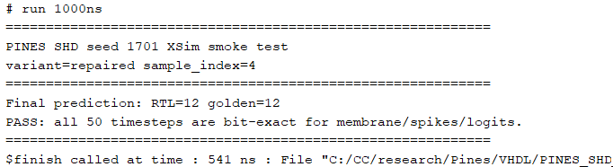

Repaired sample 5:
# run 1000ns
============================================================
PINES SHD seed 1701 XSim smoke test
variant=repaired sample_index=5
============================================================
Final prediction: RTL=5 golden=5
PASS: all 50 timesteps are bit-exact for membrane/spikes/logits.
============================================================
$finish called at time : 541 ns
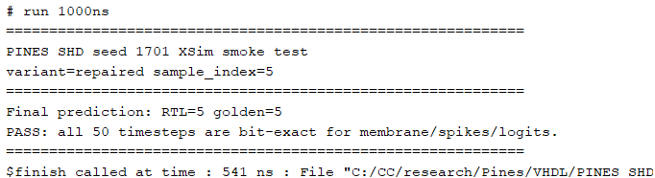

Repaired sample 6:
# run 1000ns
============================================================
PINES SHD seed 1701 XSim smoke test
variant=repaired sample_index=6
============================================================
Final prediction: RTL=15 golden=15
PASS: all 50 timesteps are bit-exact for membrane/spikes/logits.
============================================================
$finish called at time : 541 ns
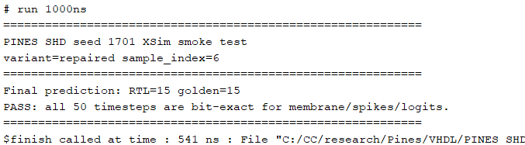

Repaired sample 7:
# run 1000ns
============================================================
PINES SHD seed 1701 XSim smoke test
variant=repaired sample_index=7
============================================================
Final prediction: RTL=2 golden=2
PASS: all 50 timesteps are bit-exact for membrane/spikes/logits.
============================================================
$finish called at time : 541 ns
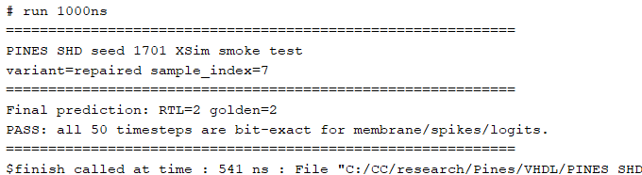

Unrepaired sample 1:
# run 1000ns
============================================================
PINES SHD seed 1701 XSim smoke test
variant=unrepaired sample_index=1
============================================================
Final prediction: RTL=15 golden=15
PASS: all 50 timesteps are bit-exact for membrane/spikes/logits.
============================================================
$finish called at time : 541 ns
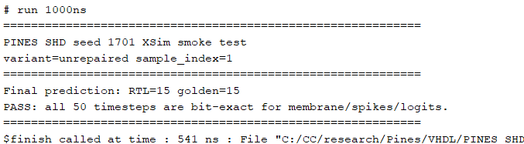

Unrepaired sample 2:
# run 1000ns
============================================================
PINES SHD seed 1701 XSim smoke test
variant=unrepaired sample_index=2
============================================================
Final prediction: RTL=6 golden=6
PASS: all 50 timesteps are bit-exact for membrane/spikes/logits.
============================================================
$finish called at time : 541 ns
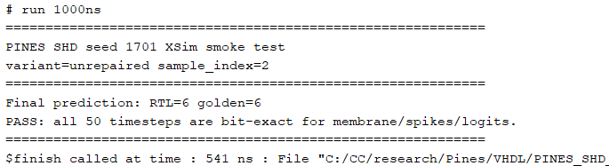

Unrepaired sample 3:
# run 1000ns
============================================================
PINES SHD seed 1701 XSim smoke test
variant=unrepaired sample_index=3
============================================================
Final prediction: RTL=15 golden=15
PASS: all 50 timesteps are bit-exact for membrane/spikes/logits.
============================================================
$finish called at time : 541 ns
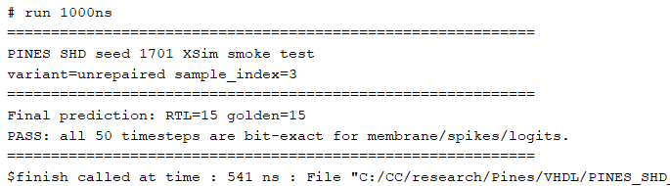

Unrepaired sample 4:
# run 1000ns
============================================================
PINES SHD seed 1701 XSim smoke test
variant=unrepaired sample_index=4
============================================================
Final prediction: RTL=15 golden=15
PASS: all 50 timesteps are bit-exact for membrane/spikes/logits.
============================================================
$finish called at time : 541 ns
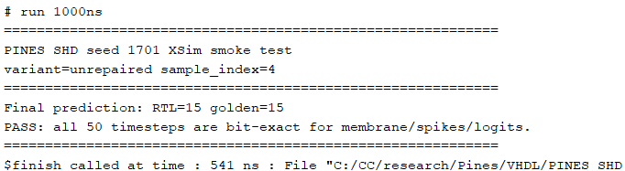

Unrepaired sample 5:
# run 1000ns
============================================================
PINES SHD seed 1701 XSim smoke test
variant=unrepaired sample_index=5
============================================================
Final prediction: RTL=15 golden=15
PASS: all 50 timesteps are bit-exact for membrane/spikes/logits.
============================================================
$finish called at time : 541 ns
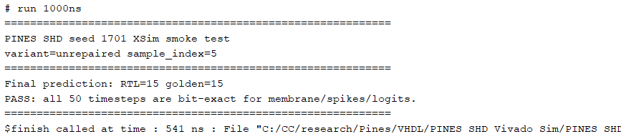

Unrepaired sample 6:
# run 1000ns
============================================================
PINES SHD seed 1701 XSim smoke test
variant=unrepaired sample_index=6
============================================================
Final prediction: RTL=15 golden=15
PASS: all 50 timesteps are bit-exact for membrane/spikes/logits.
============================================================
$finish called at time : 541 ns
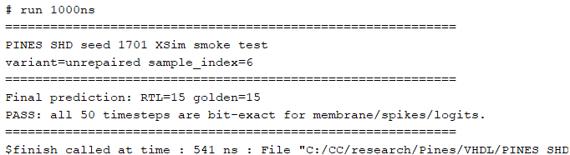

Unrepaired sample 7:
# run 1000ns
============================================================
PINES SHD seed 1701 XSim smoke test
variant=unrepaired sample_index=7
============================================================
Final prediction: RTL=2 golden=2
PASS: all 50 timesteps are bit-exact for membrane/spikes/logits.
============================================================
$finish called at time : 541 ns
